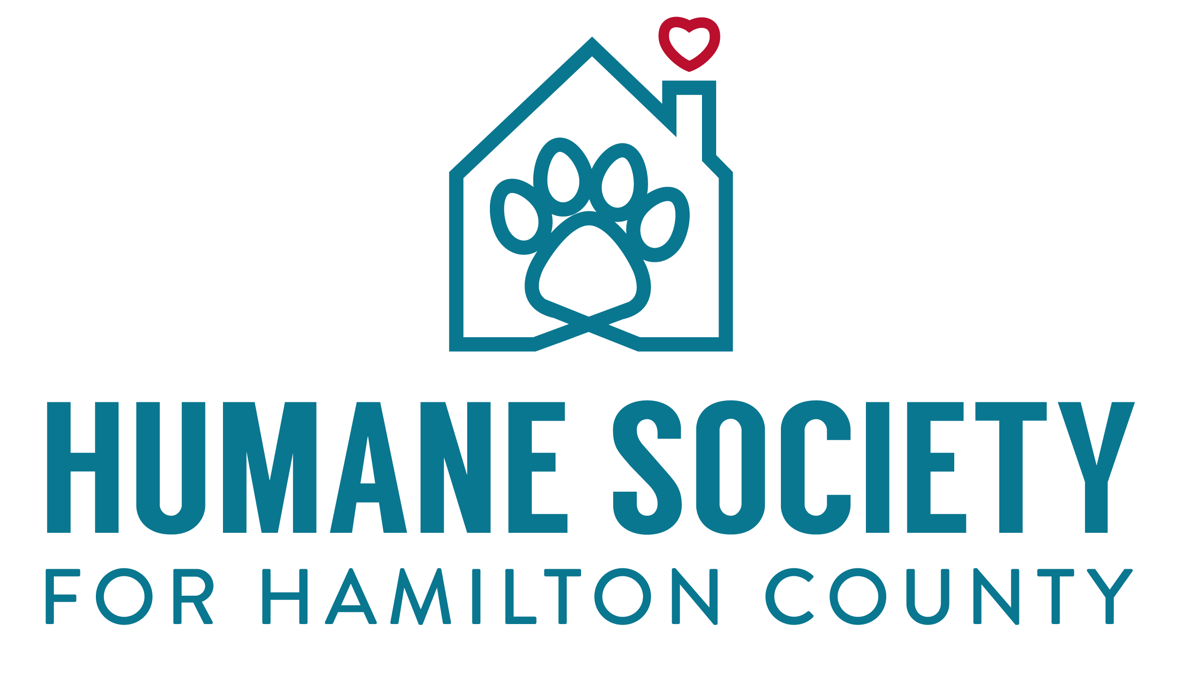

Job Title | Surgical Lead
Reports To | Medical Director of Veterinarian Services

Job Purpose

The purpose of our Surgical Lead is to provide support to the surgeon while overseeing the day-to-day operations of animals needing surgical procedures. This position will oversee the Medical Coordinators while they are functioning in the surgical department. This role serves as a liaison to all staff to ensure staff and volunteers work directly with the animals to provide proper post-operative treatment according to the plans that have been decided by staff veterinarian. Our surgery department is a fast-paced environment which will require attention to detail. This team requires strong communication skills to liaise between surgeons and shelter staff while ensuring to properly deliver post-operative care to all HSHC animals.

As the Surgical Lead, this individual will be responsible for assisting the Medical Coordinators when necessary. This individual is responsible for overseeing the day to day processes of surgery in coordination with the staff veterinarian —the goal being that adoptable animals are altered prior to going on the adoption floor as well as animal’s surgical needs are taken care of in a timely manner. This individual is responsible for coordinating with the DVS to create a daily and weekly surgical schedule.

This individual will offer conflict resolution and inspiration to the Medical Coordinator team to maximize their performance both individually and as a team. This individual is responsible for training new and existing Medical Coordinators in the surgical department to ensure they are meeting expectations. As the lead for the surgical team, you will provide feedback to the Animal Wellness Manager & DVS for Medical Coordinators for yearly reviews as well as the disciplinary process.

Duties & Responsibilities
The Surgical Lead is responsible for coordinating the surgical program including, but not limited to:

Provide new employee training to all Medical Coordinators as it pertains to the surgical department.

Perform patient assessments, anesthesia, procedures, and treatment.
- Participate in surgical procedures from induction to recovery by prepping patients for surgery, including shaving, scrubbing and positioning, assisting with intubation and performing radiographs.

Implement new processes and protocols for surgical treatments and best practices.

Evaluate the mental and physical well-being of surgical patients in conjunction with the staff veterinarian.

Successfully vaccinate, draw blood, and give injections needed for surgical procedures.

Process all surgical paperwork and enter into PetPoint database same day.

Track surgical inventory and stay on track with yearly shelter budget.

Order surgical consumables weekly and surgical instruments as need.

Manage appointments, obtain patient histories, keep medical records, patient discharges, etc. for animals outside of HSHC’s care.

Create a schedule for any surgeries that need completed for animals outside of HSHC’s care.

Fill medications and maintain accurate medical records.

Create a reliable surgery schedule to ensure all animals are spayed/neutered prior to adoption as well as surgical needs for animals are met in house.

Ensure documentation is accurate and complete.

Open, turn over and clean operating rooms, as well as clean instruments and wrap packs.

Assist veterinarian in medical procedures and surgeries.

Create and maintain a daily surgical schedule for all HSHC animals.

Fill in for Medical Coordinator roles when necessary.

Maintain all yearly inspections of medical equipment.

Qualifications, Applicants must:
Philosophically

- Embrace our No-Kill philosophy and whatever it takes attitude.
Hard Skills
- Be a State Registered Veterinary Technician or have equivalent experience working in a veterinary surgical are capacity with a proven and successful track record.
- Have a minimum of 2 years of experience managing/supervising others.

Have applied experience and demonstrated success identifying and developing a treatment plan for common medical conditions/illnesses associated with dogs and cats, especially in a shelter environment. This includes, but is not limited to: upper respiratory infections, heartworm disease, ringworm, demodex/sarcoptic mange, other skin infections, ear and eye infections, thyroid conditions, etc.

Be knowledgeable about shelter related, contagious illnesses with an understanding of how to 1) identify such conditions, 2) establish the appropriate handling or quarantine plan, and 3) implement the appropriate medical treatment plan.
- Be highly proficient using a computer including experience using Microsoft Office, email, and entering/searching for information in data management software such as PetPoint, Excel, or other equivalent database.
- Be able to lift a minimum of 50 lbs. without health risk.
- Proficient in calculations (drugs, constant rate infusions, unit conversions, etc.)
Soft Skills/Other
- Be a self-starter with excellent problem solving skills and initiative.
- Be an excellent communicator—both written and verbal.
- Be comfortable navigating difficult and stressful situations that may require conflict resolution between employees and/or customers.
- Be able to pivot and react quickly to the unplanned challenges that often occur in our world each day.
- Be flexible to work some nights and weekends.
- Thrive in a fast paced work environment where you are surrounded by the distractions of animal sounds, smells, and their respective allergens.
I have read the above job description. I agree that I can perform all duties outlined in the above description.

__________________________ _______________
Date
Employee Signature

__________________________ _______________
Date
Supervisor Signature

