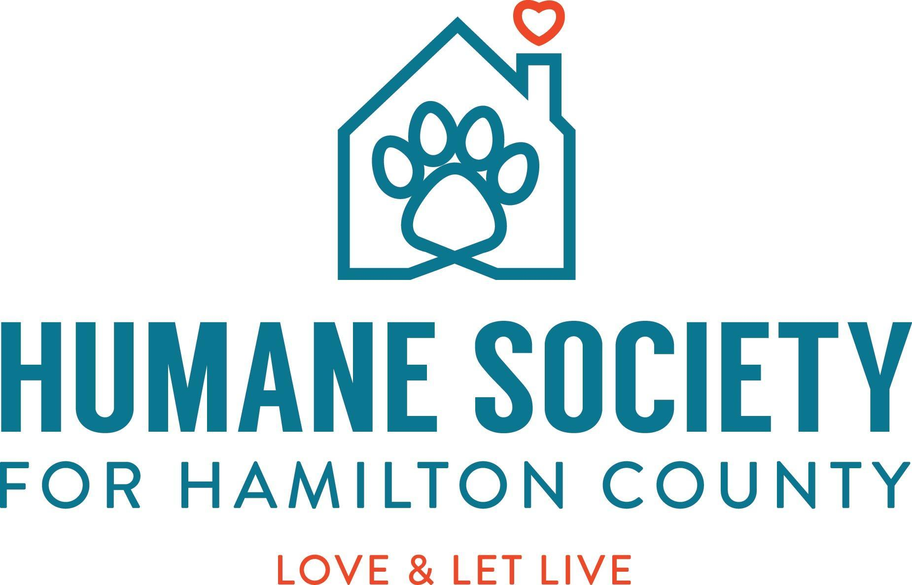

Job Title | Human Resources Manager
Reports To | President and CEO
Starting Salary Range | $45,000 - $55,000

Job Purpose:

The Human Resource Manager is responsible for overseeing and fulfilling all HR needs for the organization including continued recruitment for all open positions (utilizing a variety of online resources like Indeed), scheduling interviews for applicants in collaboration with the hiring manager, checking professional references, facilitating background checks and drug testing when appropriate. The HR Manager is responsible for ensuring all new hires are set up in our Human Resource Information System, all required hiring documentation is in order, and all other onboarding and orientation items are set into motion.

The HR Manager ensures all staff are informed of benefits eligibility and will serve as a resource to all employees regarding their benefits. These benefits include health insurance options, and paid time off/vacation. The HR Manager will guide employees in enrolling in benefits, setting up an HSA, and tracking time off requests, for example. Time off requests may also include unpaid leaves of absence and FMLA. As accommodations are requested, the HR Manager will also guide employees through the ADA process.

The HR Manager is responsible for processing weekly payroll through our HR partner, Worksmart, and ensuring hourly timecards are reviewed for any discrepancies, concerns, and that overtime reported by staff has been approved.

The HR Manager works closely with the President to ensure the President is informed of any employee concerns involving a direct report of the President, as well as any other employee concerns that should be brought to the President’s attention. This role also works closely with all directors and department managers to support their HR tasks including performance reviews, preparing and delivering disciplinary reviews, tracking results/implementation of performance improvement plans, and ensuring that all new hires receive proper training as outlined for each role—whether it be the on-boarding of a new employee or continued training that may be required for a specific role.

The HR Manager serves as an objective listener with an open door to all employees to share their concerns. It is critical that concerns are documented and addressed appropriately. The HR Manager must take the time to understand the points being made, ask appropriate questions, and use logic and reasoning to identify resolutions for both the employee and employer.

Duties & Responsibilities:
- Support recruiting efforts by developing requisitions, facilitating candidate logistics, scheduling and administering the onboarding training/orientation process.
- Schedule and facilitate new hire onboarding which includes creating employee files, completing new hire paperwork, reviewing policy and procedures, assigning employee numbers and shelter tour.
- Administer weekly payroll. Use payroll system to produce accurate and timely payroll processing.
- Administer all company benefits: including new enrollments, change of status and open enrollment.
- Source and place interns as requested.
- Process wage increases, status changes, termination paperwork and conducts exit interviews.
- Upkeep all personnel files.
- Provide training to staff for all items related to HR.
- Oversee the execution of the annual performance review process. Support and follow up on all personal development plans. Support managers in resolving staff conflict and addressing performance opportunities in a timely manner.
- Lead staff recognition programs which include: employee/volunteer of the month, birthdays, anniversaries.
- Provide guidance to managers and team regarding, accident/incident reports, workman’s compensation, employee relations practices and company policies and procedures.
- Manage workman’s compensation process.
- Work with the Facility Manager to assign facility keys in partnership with county officials.
- Work with Facility Manager to process paperwork to provide van insurance to applicable employees.
- Collect and analyze data for HR processes and programs, including creating reports and queries for managers as needed.

Qualifications:

Philosophical

- Embrace our No-Kill philosophy and whatever it takes attitude.
- Understand that the role of an HR Manager is to be objective, consistent, and equitable working toward solutions that fulfill our commitment to employees, while also upholding their compliance responsibility to Humane Society for Hamilton County.
- Must be able to navigate employee conflicts in a professional and confidential manner at all times and may sometimes serve as the intermediary between employees. Other situations may require disciplinary action, in collaboration with the appropriate manager/director/President. Must foster compliant solutions which are appropriate for the Humane Society for Hamilton County.

Experience and Skills

- Bachelor’s Degree
- Minimum 3 years’ experience as a HR Generalist or significant exposure to HR functions
- Member of the Society for Human Resource Management (SHRM) is a plus
- Recruitment: proficiency in writing job descriptions, posting job openings to online recruitment tools, tracking applicants, and conducting interviews and reference checks.
- Payroll: capable of processing payroll and managing vacation/paid time off.
- Conflict Resolution/Negotiation: experience managing conflict while working toward the goal of identifying the best possible resolution that protects both employee and employer.
- Compliance: deep understanding of state and federal requirements across a wide range of HR functions, including OSHA regulations, employee safety training and managing workman’s compensation claims.
- Communication & Presentations: excellent written and oral communication skills with the ability to conduct new hire orientations that are interesting and effective.
- Microsoft Office Proficiency: Word, Excel, PowerPoint, Google Docs, Email, and general recruitment databases like Indeed, LinkedIn, etc.
- Scheduling: flexible to work some evenings and weekends to address emergency situations.
- Environment: able to excel in a fast-paced work environment where you are surrounded by the distractions of animal sounds, smells and their respective allergens
- Physical: must be able to lift a minimum of 25lbs on a regular basis

Benefits Package:
- Full-Time employees are eligible for benefits after 60 days of employment. HSHC offers several insurance options, including but not limited to medical (Anthem), dental, vision, Long/Short Term Disability, FSA/HSA, Identity Theft Protection, and Life Insurance.
- Generous vacation and paid time off accrued from day one.
- Robust Pet Benefits Package for employee owned pets. Includes annual vaccines, diagnostics, x-rays, preventatives, and prescription medications (requires a DVM script) at cost. Other select pet supplies like potty pads, carriers, food, bowls, bedding, etc. are available at no cost in the designated ‘free’ storage bins.
- Certifications/Professional Development Training provided/funded by HSHC based on role and relevance.
- Retirement plan option available.

-------------------------------------------------------------------------------------------------------------------------------------------------------------
Qualified candidates should apply online OR email a resume and cover letter to humanresources@hamiltonhumane.com.
Thank you for your interest in pursuing a career at the Humane Society for Hamilton County. HSHC is an equal opportunity employer. All qualified applicants will receive consideration for employment without regard to their race, color, religion, ancestry, national origin, sex, sexual orientation, age, disability, marital status, gender identity, domestic partner status, or any other status protected by federal, state, or local law. Applicants are not required to live in Hamilton County.
This job description in no way states or implies that these are the only duties to be performed by the employee(s) of this position. All duties and responsibilities are essential functions and requirements and are subject to possible modification to reasonably accommodate individuals with disabilities.

